**Bridge Pattern**

* **Introduction:**
  + Our implementations and abstractions are generally coupled each other in normal inheritance.
  + Using bridge pattern we can decouple them so they can both change without affecting each other.
  + We achieve this feat by creating two separate inheritance hierarchies; one for implementation and another for abstraction.
  + We use composition to bridge these two hierarchies.
* **UML:**

* **Implementation Steps:**
  + We start by defining out abstraction as needed by client.
    - We determine common base operations and define them in abstraction.
    - We can optionally also define a refined abstraction & provide more specialized operations.
    - Then we define our implementor next. Implementor methods do not have to match with abstractor. However abstraction can carry out its work by using implementor methods.
    - Then we write one or more concrete implementor providing implementation.
  + Abstractions are created by composing them with an instance of concrete implementor which is used by methods in abstraction.
* **Example UML:**

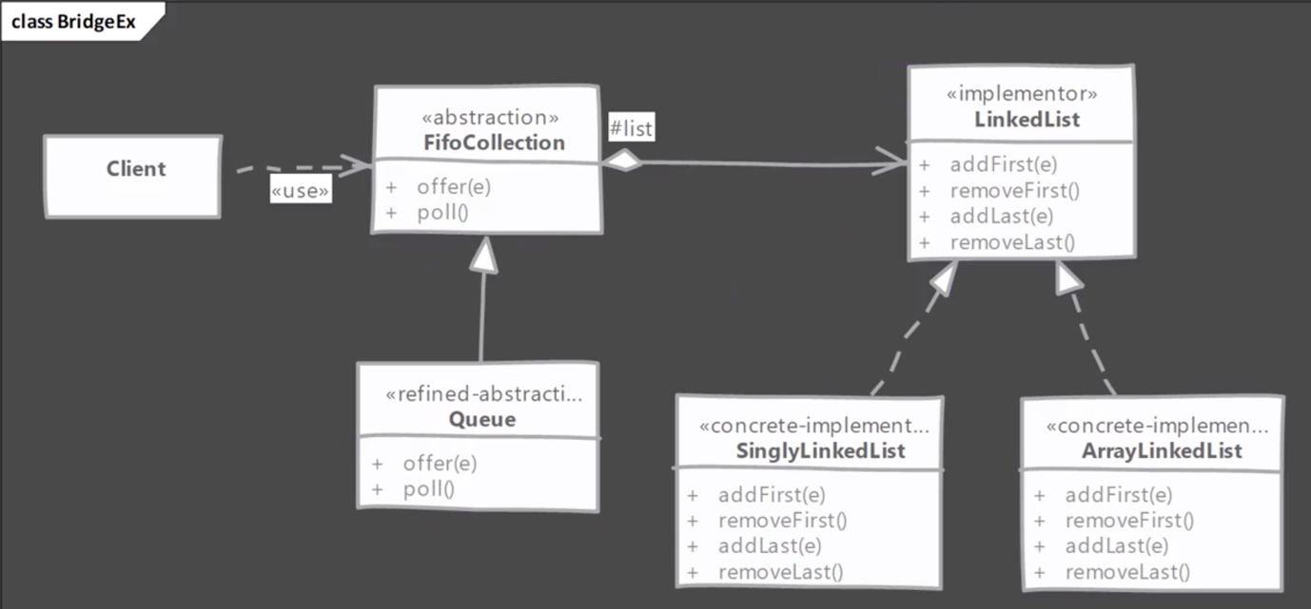

* **Implementation & Design Consideration:**
  + In case we are ever going to have a single implementation then we can skip creating abstract implementor
  + Abstraction can decide on its own which concrete implementor to use in its constructor or we can delegate that decision to a third class. In last approach abstraction remains unaware of concrete implementors & provides greater decoupling.

**Design Consideration:**

* + Bridge provides greater extensibility by allowing us to change abstraction and implementor independently. You can build and package them separately to modularize overall system.
  + By using abstract factory pattern to create abstraction objects with correct implementation you can decouple concrete implementors from abstraction.
* **Example:**
  + An example of bridge pattern often given in the JDBC API. More specifically the java.sql.DriverManager class with the java.sql.Driver interface form a bridge pattern.

* + An example of bridge pattern often given is the Collections.newSetFromMap() method. This method returns a Set which is backed by given Map object.

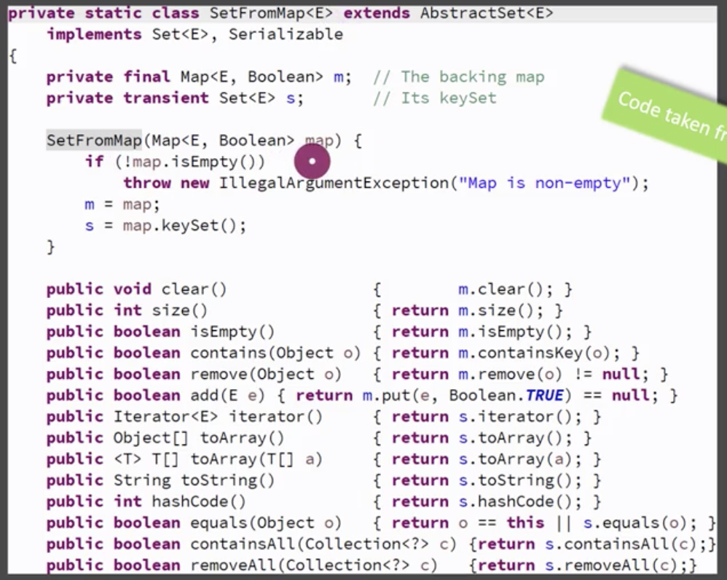

* **Comparison with Adapter:**

|  |  |
| --- | --- |
| **Bridge** | **Adapter** |
| Intention is to allow abstraction and implementation to vary independently. | Adapter is meant to make unrelated class work together. |
| Bridge has to be designed up front then only we can have varying abstractions and implementations. | Adapter finds its usage typically where are legacy system is to be integrated with new code. |

* **Pitfalls:**
  + It is fairly complex to understand & implement bridge design pattern.
  + You need to have a well thought out & fairly comprehensive design in front of you before you can decide on bridge pattern.
  + Needs to be designed up front. Adding bridge to legacy code is difficult. Even for ongoing project adding bridge at later time in development may require fair amount of rework.
* **Quiz:**



